Alexander Davis

S14110259

BSc Computer Science

Birmingham City University

Word Count: 1995

Critical Literature Review Into the Effectiveness of Social Media within Mental Health Services

CMP6102 Individual Project (CTN) UG3

Contents

Introduction 3

Overview of Literature on The Effectiveness of Social Media within Mental Health Services 4

Thematic Comparison of Literature On the Effectiveness of Social Media Within Mental Health Services 6

The Deployment of Mental Health Services 6

Mental Health Servces in the United States of America 6

Mental Health Servces in the United Kingdom 6

The Concept of Social Media 7

Different Types of Social Media Platform 7

The Uses of Social Media 7

The Use of Social Media Within Mental Health Services 8

Adoption within Education Institutions 11

Conclusion 12

References 13

Glossary 15

# Introduction

The growing use of **Social Media** within popular culture has shown that today’s society is more willing to share with others on a public **forum** their personal and social activities such as shopping, eating out and watching films.

Unfortunately, **Mental Health Issues** are rarely brought up online on social media platforms however many awareness groups, education institutions and healthcare providers around the world are starting to create and utilise the social media platforms to provide support and advice for those who require it. For example, the Birmingham City University Student’s Union (BCUSU) created and formed a mental health awareness society within the university. The Birmingham City University Mental Health Awareness (BCUMHA) Society’s mission is stated on Facebook.

“Raising awareness, tackling stigma, and enhancing the student experience for those who suffer from a mental health illness at Birmingham City University”

(Birmingham City University Mental Health Awareness et al., 2016)

Since the formation of BCUMHA and similar societies at other universities, students have been discussing and raising issues within their university and provided feedback on the support they have been offered.

# Overview of Literature on The Effectiveness of Social Media within Mental Health Services

Table 1 (shown below) contains all journal articles the author has selected surrounding the topic of the use of social media within mental health services.

|  |  |  |  |
| --- | --- | --- | --- |
| **Authors** | **Year** | **Paper Title** | **Paper Summary** |
| Moorhead et al | 2013 | A New Dimension Of Health Care: Systematic Review Of The Uses, Benefits, And Limitations Of Social Media For Health Communication | This paper researches into the uses and effects of using social media platforms to communicate between healthcare provider and patient. The paper identifies recommendations to enable general health communication to become more effective. |
| Hoge et al. | 2006 | Mental Health Problems, Use Of  Mental Health Services, And Attrition  From Military Service After Returning  From Deployment To Iraq Or Afghanistan | This paper looks into the mental health care provided to military personnel coming back from combat areas and how the use of mental health screening has allowed the care provided to be of a higher standard. |
| Maulik et al. | 2009 | The Role Of Social Network And Support In Mental Health Service  Use: Findings From The Baltimore ECA Study | This paper examine the possibility and the effects of using social media to treat mental health issues. |
| Orlowski et al. | 2016 | The Promise And The Reality: A Mental Health Workforce Perspective On Technology-Enhanced Youth Mental Health Service Delivery | Similar to the previous article, this paper examines the effects of using social media to treat mental health issues however this paper focuses on mental health issues faced by younger people and how social media can be used. |
| Rosenbaum et al. | 2012 | The Effect Of Instant Messaging Services On Society’s Mental Health | This paper shows how **instant messaging services** affect societal mental health within this 18-30 age group. It also looks into the issues of internet addition within this age group and its effect on their mental health. |
| Blanchard | 2011 | Navigating The Digital Disconnect | Blanchard looks into the strategies and their effectiveness of using new technologies to impact the mental health and wellbeing of young people aged 12 to 25. |
| Crown copyright | 1983 | **The Mental Health Act 1983** | This legislation defines all circumstances for admission for mental health issues and guidelines and policies for the care of patients with mental health issues. |
| Great Britain. Department of Health | 1999 | Mental Health: Modern Standards And Service Models: Executive Summary | This book issues the standards that all NHS trusts within the United Kingdom should follow and adhere to. It includes guidelines on treatment and care. |

**Table 1 – An Overview of the Academic Literature Surrounding the Effectiveness of Social Media within Mental Health Services**

# Thematic Comparison of Literature On the Effectiveness of Social Media Within Mental Health Services

## The Deployment of Mental Health Services

Mental health services differ within each country; this critical literature review will focus mainly on the services provided within the United Kingdom and the United States of America.

### Mental Health Servces in the United States of America

Mental health services within the United States of America (USA) are provided by private companies who require payment from each recipient of their services.

The United States Military provides a service for personnel that assesses them for possible health issues created from working within the **combat zones**. This service begins with a form called the Post-Deployment Health Assessment form (PDHA). This allows the military to arrange and deliver specific healthcare treatments, including any mental health services to their staff. This service has a positive effect on the users of the service within the first year however statistics for after the first year of service are incomplete as stated in Hoge’s paper,

“This study provides new data showing the strong relationship between combat duty and a variety of mental health outcomes and most importantly high mental health care utilization in the first year after deployment. … Additional research is needed beyond a year after deployment to determine the long-term burden that this war will have on the mental health care system.”

(Hoge et al., 2006)

### Mental Health Servces in the United Kingdom

Mental health services within the United Kingdom is generally funded by the **National Health Service (NHS).** The NHS is currently aiming to cut down operational costs for these services. In 1999, the then Secretary of State for Health Frank Dobson MP, announced

“The Government is committed to do whatever is necessary to deliver a modern and dependable health service ... Mental health services and the professionals who provide them will get the attention and resources they deserve”

(Great Britain. Department of Health, 1999)

These commitments have not been fulfilled as the country has since experienced several recessions that have overshadowed the improvement to mental health services.

There is however stricter guidelines on providing efficient and quality mental health services. The Mental Health Act 1983 states all guidelines for the delivery and protection of mental health services.

“(1)It shall be an offence for any person who is an officer on the staff of or otherwise employed in…

(a)to ill-treat or wilfully to neglect a patient for the time being receiving treatment for mental disorder as an in-patient …

or

(b)to ill-treat or wilfully to neglect, … a patient for the time being receiving such treatment there as an out-patient.

(2)It shall be an offence for any individual to ill-treat or wilfully to neglect a mentally disordered patient who is for the time being subject to his guardianship under this Act or otherwise in his custody or care.”

(Crown copyright, 1983)

## The Concept of Social Media

Social media has become one of the human rights in some countries with many people who use the internet owning one or more social media accounts.

Social media platforms promote **freedom of speech** also as they are generally ungoverned and have in the past allowed those who are in oppressed countries to publicise the internal events going on.

### Different Types of Social Media Platform

There are approximately 8 different social media platform categories; Social Networking, Video Sharing, Live-Streaming, Microblogging, Blogging, Social News, Photo Sharing and Content Curation. The most popular platforms for each category are Facebook, YouTube, Twitch, Twitter, WordPress, Reddit, Instagram and Pinterest respectively.

## The Uses of Social Media

Many people well known within popular culture gain their popularity and ‘fame’ from using their social media accounts. The most famous case for this is Kim Kardashian who frequently publishes suggestive images of herself online to explicitly gain controversy.

Other users of social media platforms include tutorials, news articles, advertising, gameplay and general ideas for projects.

Many countries security services use these social networks to monitor possible security threats such as suspected terrorists. The United States of America’s **National Security Agency (NSA)** utilises social media to monitor security targets as Joseph Verble states in his paper.

“The NSA became the management system for the … researchers into new computer technology and communications infrastructure.”

(Verble, 2014)

## The Use of Social Media Within Mental Health Services

Recently, mental healthcare providers have been trialling the use of social media and online platforms for providing support and advice to their patients. Several journal articles suggest that online treatment would benefit however careful consideration on the design and use of the platforms should be observed. Orlowski states

While the benefits of technology were seen in the ability to more closely track consumers’ progress and level of risk, it was also associated with concerns around an implied level of clinician responsivity and possible increases to workload. These concerns included a perceived lack of processing around information communicated via these modes of communication and unclear guidelines around when and how clinicians should respond to potentially risky information, particularly outside of work hours.

(Orlowski et al., 2016)

Social media can also be used by the general public to assess someone’s mental health although the system is heavily reliant on each person’s. This has already been implemented on Facebook where users can report those who are at risk of harming themselves or someone else. Figures 1, 2 and 3 show the advice and guidance Facebook provides its users who can either refer themselves or someone else to a mental health service.

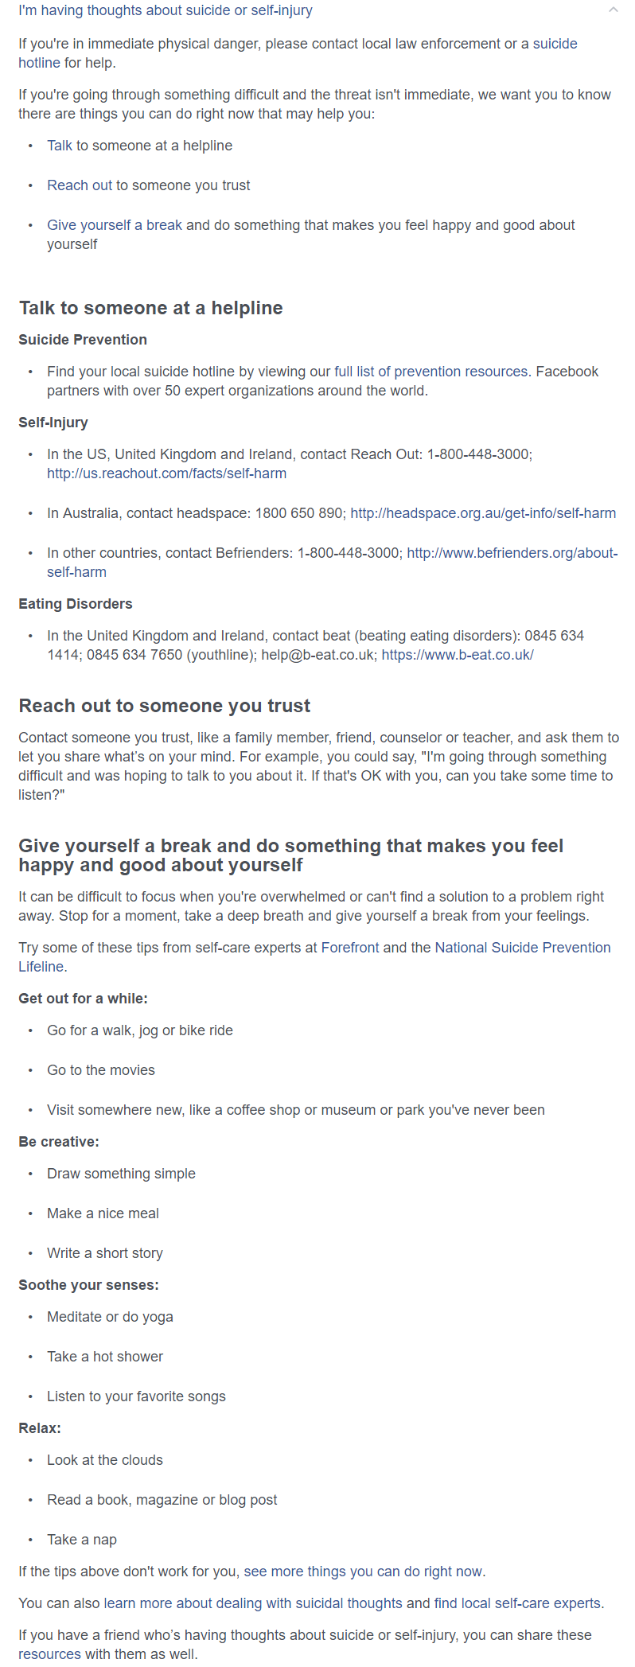

Source: (Facebook, 2017)

Figure 1 – Question giving advice regarding mental health issues

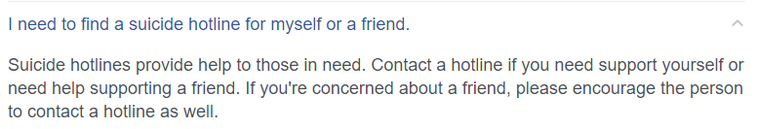

Source: (Facebook, 2017)

Figure 2 – Question giving advice regarding mental health issues

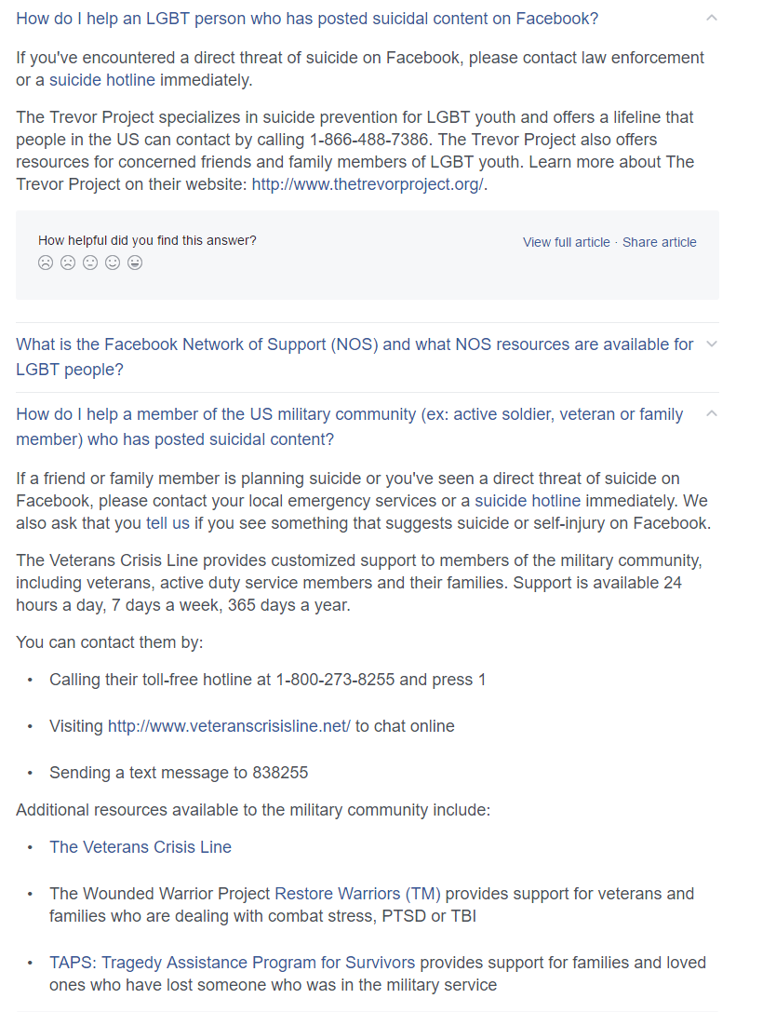

Source: (Facebook, 2017)

Figure 3 – Question giving advice regarding mental health issues

Researchers have also found that the use of social media specifically the reduced contact between friends and family affected the odds of accessing mental health services. Maulik states

“The effect of social network and social support on general medical service use indicated that a reduced frequency of contact with either friends or relatives was associated with reduced odds of accessing services across different mental health conditions.”

(Maulik et al., 2009)

This demonstrates that mental healthcare providers should begin advertising and offering support on social media platforms as this would greatly increase the usage of their services and allow more flexibility with appointments. It would also ensure that people suffering with anxiety disorders are able to attend their appointments regardless of being in the provider’s facility or not.

The use of social media within healthcare can also be used within general healthcare also. The usage of services such as **WebMD** increase engagement and the awareness of other health conditions. Moorhead states

“Social media brings a new dimension to health care as it offers a medium to be used by the public, patients, and health professionals to communicate about health issues with the possibility of potentially improving health outcomes.”

(Moorhead et al., 2013)

### Adoption within Education Institutions

Education institutions have been very hesitant to incorporate social media into their wellbeing programmes as there is evidence to suggest that students’ conditions may worsen if services are accessed using social media platforms. Rosenbaum demonstrates this saying

“research shows that internet addiction may exacerbate ADHD symptoms in adolescents”

(Rosenbaum et al., 2012)

Institutions may also be hesitant due to the cost of implementing such a service and developing procedures and training staff as demonstrated in Blanchard’s article.

“Information communication technologies have great potential in improving young people’s mental health ... However, if this potential is realized, guidelines for their safe and effective use need to be developed. Furthermore, investment needs to be made in securing appropriate technology infrastructure … and in training staff to better understand young people’s use of technology.”

(Blanchard, 2011)

# Conclusion

The use of social media within mental healthcare allows more organisations to provide a more efficient service without affecting the quality at a lower cost compared to traditional methods such as face to face appointments.

The future of social media and mental health services is very unpredictable as many organisations are incredibly hesitant to start using social media platforms however as more digital devices including **The Internet of Things** devices become popular, the use of social media and mental health services may grow and become the main method for individuals to access these services.

# References

Birmingham City University Mental Health Awareness, Goodman, J. and Davis, A. (2016) Birmingham City University Mental Health Awareness Society. Available at: https://www.facebook.com/bcumha/ [Accessed 6 December 2016].

Blanchard, M. (2011) 126. Navigating the digital disconnect: Understanding the use of information communication technology by the youth health workforce to improve young people’s mental health and wellbeing. Journal of Adolescent Health, 48(2), pp. S83–S83. Available at: http://dx.doi.org/10.1016/j.jadohealth.2010.11.174.

Mental Health Act (1983).

Facebook (2017) Help Center: Safety Resources. Available at: https://www.facebook.com/help/748040478549007?helpref=faq_content [Accessed 1 January 2017].

Great Britain. Department of Health (1999) Mental health: modern standards and service models: executive summary. London: Department of Health.

Hoge, C. W., Auchterlonie, J. L. and Milliken, C. S. (2006) Mental health problems, use of mental health services, and attrition from military service after returning from deployment to Iraq or Afghanistan. JAMA, 295(9), p. 1023. Available at: http://dx.doi.org/10.1001/jama.295.9.1023.

Leon, R.-D. and Marcu, L. M. (2016) Social Media Platforms as a Tool for Sharing Emotions. A Perspective upon the National Security Agencies. Management Dynamics in the Knowledge Economy, 4(1), pp. 141–152.

Maulik, P., Eaton, W. and Bradshaw, C. (2009) The role of social network and support in mental health service use: Findings from the Baltimore ECA study. Psychiatric Services, 60(9). Available at: http://dx.doi.org/10.1176/appi.ps.60.9.1222.

Moorhead, S. A., Hazlett, D. E., Harrison, L., Carroll, J. K., Irwin, A. and Hoving, C. (2013) A new dimension of health care: Systematic review of the uses, benefits, and limitations of social media for health communication. Journal of Medical Internet Research, 15(4), p. e85. Available at: http://dx.doi.org/10.2196/jmir.1933.

Nami, Y., Nami, M. S. and Eishani, K. A. (2014) The students’ mental health status. Procedia - Social and Behavioral Sciences, 114, pp. 840–844. Available at: http://dx.doi.org/10.1016/j.sbspro.2013.12.794.

Orlowski, S., Lawn, S., Matthews, B., Venning, A., Wyld, K., Jones, G., Winsall, M., Antezana, G., Schrader, G. and Bidargaddi, N. (2016) The promise and the reality: A mental health workforce perspective on technology-enhanced youth mental health service delivery. BMC Health Services Research, 16(1). Available at: http://dx.doi.org/10.1186/s12913-016-1790-y.

Rosenbaum, M. S. and Wong, I. A. (2012) The effect of instant messaging services on society’s mental health. Journal of Services Marketing, 26(2), pp. 124–136. Available at: http://dx.doi.org/10.1108/08876041211215284.

Verble, J. (2014) The NSA and Edward Snowden. ACM SIGCAS Computers and Society, 44(3), pp. 14–20. Available at: http://dx.doi.org/10.1145/2684097.2684101.

# Glossary

**Combat Zones –** An area where military forces operate

**Forum –** An online service that allows the views of others to be promoted

**Freedom of Speech –** The concession for someone to speak without restraints from authorities

**Instant Messaging Services –** An online service that provides real-time conversations to take place

**Mental Health Issues –** Defined disorders that affect mood, thinking and behaviour

**National Health Service –** A publicly funded healthcare organisation within the United Kingdom

**National Security Agency –** An intelligence gathering organisation of the United States government

**Social Media –** Online services that allow users to share content with others

**The Internet of Things –** General household appliances that connect to the internet

**The Mental Health Act 1983 –** An act of the Parliament of the United Kingdom that covers the delivery of mentally disabled people

**WebMD –** An online publisher of information regarding health and wellbeing